What Time is it?
Polaris time clock activity

Name: Date: Period:

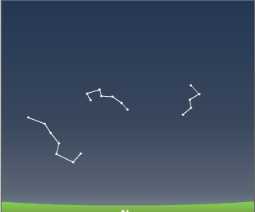
- If this is the sky on October 31st, what time is it?

- If this is the sky for February 15th, what time is it?

- Draw the positions of the Big Dipper, Little Dipper, and Cassiopeia for 9:00 pm on November 25th.

- Find a date and time at night when you would see the stars as they would look if you could see them on May 15th at noon.

- What time of year can you see the Big Dipper high in the sky at 10:00 pm? (Think the seasons.)

- What direction, in relation to your Zenith, will the constellations on this time wheel move through the night? (Clockwise or counterclockwise?) Explain how you figured this out, and how you can prove it using the Star Clock.

Using your Polaris Star Clock outside
- Placing the correct month towards your Zenith, turn the dial to match the constellations. Record the date: _____________________, and time: ____________________. Draw a sketch showing the Big Dipper, Little Dipper and Cassiopeia as it appears now.

- Does the time match on your star circle with the time on the clock? If it doesn’t match, how far off is it? Why do you believe it does or does not match?

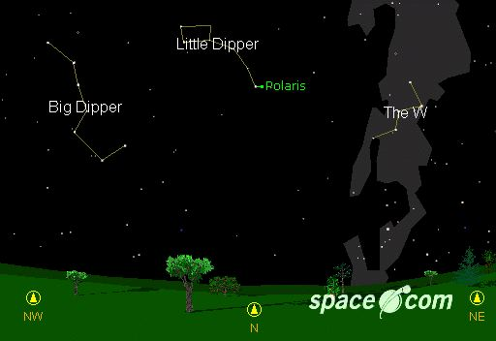
- Look for the Milky Way, it will be located around Cassiopeia and will stretch across the night sky, looking like spilled milk. You are actually looking though the center bulge of our Milky Way galaxy. Sketch the Milky Way on your Time Clock.

- Look at the Big Dipper; can you spot the double star system? (Use binoculars). If you can see it, draw the Big Dipper (all 7 stars) below including the double star system, and CIRCLE the double star system.

- Sketch below how the constellation of the Big Dipper, Small Dipper and Cassiopeia will look next month at 10 pm. Beside it sketch how the same constellation will look at the end of the school year in June at 10 pm.
Next Month In June

