Name _____________________________ Block____________
Notes: What makes a planet habitable?

Circumstellar Habitable Zone (CHZ) “Goldilocks Zone”– is the ________________ around a star within which ______________________-________________ objects with sufficient ___________________ __________________ can support __________________ ___________________ at their surfaces.

Sketch our CHZ

Not too hot, not too cold (T________________________________):
Liquid water is ______________ to exist on the _________________ of a planet.
Too Close – Water ________ _________ the surface
Too far – Water is ____________, not allowing for molecules to ______ and _________
Our solar system has ______ planet in the Goldilocks Zone (_______-_______ AU)
____________ (But ________ had __________ water at one time)
________________________ habitable zone (_______-_______ AU-extended to Ceres)
Could Venus’s atmosphere be ___________ to allow liquid water to exist?
Why is “liquid” water important instead of ice/steam?

Not to big not too small (_________)
Planets need to have sufficient _____ to hold onto its _________________, Mars _______ most of its atmosphere. If planet is too big, ______________ could limit the development of life.

What type of star is it?
To determine the habitable zone you need to know total ________________ a star emits.
OBAFGKM- Our star is ____-class
Massive stars- ______________, _____________ with radiation, zone is _______________ ________.
Live for __________time, not ____________ time for life to ______________
Smaller stars- ________________ belts than our sun, __________________ to the star
Live for __________ time, more ________________ for life to evolve.
Ex. Kepler-62f, takes ________ days to complete an orbit
Best stars to search are ______-____ class, _____-_____ don’t live long enough

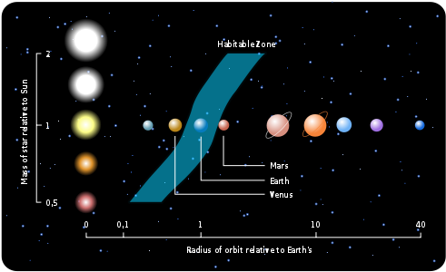
How does the HZ change with difference star types?

Is that star stable?
Solar ___________ from a star could ______________ a planet in ____________________.
New stars/old stars- ___________________ in radiation
Middle-aged star – radiation tends to be _________________
Liquid water- ____________ high amount of radiation, could _____________ life underwater
A planet’s chemistry?
Would a white dwarf be a good place to look for life?
A planet’s atmosphere will ________________ a certain amount of energy from starlight and ____________________ the rest back out.
Atmosphere- Tends to _________ heat, more CO₂ or methane can ______________ the greenhouse effect and _____________ the zone.
Energy that is trapped- difference between _________________________ sea vs. ________________________ volcanoes
Atmosphere- look for ___________________, ______________________, ____________________ and _______________________ (could indicate life).
Could Venus’ atmosphere be transferred to Mars? What would our HZ be like then?

CHZ Controversy- Other ways for liquid water -____________ ______________, ___________________ ________________, or ____________________________ by other non-atmospheric means, and basic conditions of life in interstellar __________ on __________ planets or their __________________. Non-water _________________ to hypothetical life based on ____________________ biochemistries.
Why shouldn’t a super Jupiter out past a HZ be ruled out for harboring life?
Galactic Habitable Zone : Area in a galaxy where ______ has the best ___________ of occurring.
Too close to the __________________, star density increases, greater chance of being taken out by a ____________________ explosion.
Too far out, less stars to ________________ the heavier ____________________ necessary for planets and life to form.
Why is it necessary to have a 2nd generation solar system to harbor life vs. a 1st generation solar system?
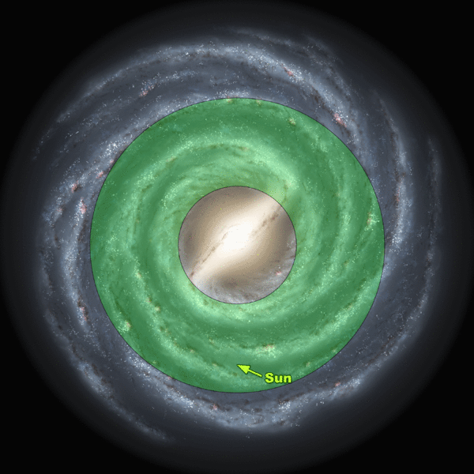
Where is the best places to look for the possibilities of life in our solar system?

