Name _____________________________

Notes: What makes a planet habitable?

Circumstellar Habitable Zone (CHZ) “Goldilocks Zone”– is the region around a star within which planetary-mass objects with sufficient atmospheric pressure can support liquid water at their surfaces.

Not too hot, not too cold (Temperature):
Liquid water is needed to exist on the surface of a planet.
Too Close – Water boils off the surface
Too far – Water is frozen, not allowing for molecules to mix and interact
Our solar system has one planet in the Goldilocks Zone (0.9-1.2 AU)
Earth (But Mars had liquid water at one time)
Extended habitable zone (0.75-3.0 AU-extended to Ceres)
Could Venus’s atmosphere be thinned to allow liquid water to exist?

Not to big not too small (size)
Planets need to have sufficient size to hold onto its atmosphere, Mars lost most of its atmosphere. If planet is too big, gravity could limit the development of life.

What type of star is it?
To determine the habitable zone you need to know total radiation a star emits.
OBAFGKM- Our star is G-class
Massive stars- hotter, blaze with radiation, zone is further out.
Live for short time, not enough time for life to evolve
Smaller stars- tighter belts than our sun, closer to the star
Live for longer time, more chance for life to evolve.
Ex. Kepler-62f, takes 267 days to complete an orbit
Best stars to search are F-M class, O-A don’t live long enough

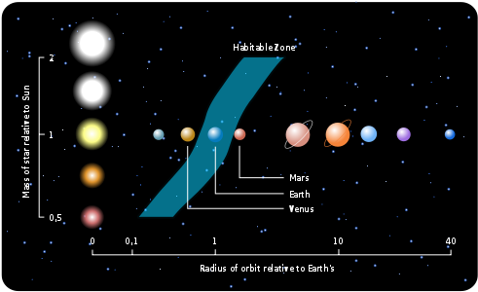

Is that star stable?
Solar eruption from a star could bathe a planet in radiation.
New stars/old stars- variations in radiation
Middle-aged star – radiation tends to be constant
Liquid water- absorbs high amount of radiation, could protect life underwater

A planet’s chemistry?
A planet’s atmosphere will absorb a certain amount of energy from starlight and radiate the rest back out.
Atmosphere- Tends to trap heat, more CO2 or methane can increase the greenhouse effect and extent the zone.
Energy that is trapped- difference between turquoise sea vs. erupting volcanoes
Atmosphere- look for oxygen, water, carbon dioxide and methane (could indicate life).

CHZ Controversy- Other ways for liquid water -tidal heating, radioactive decay, or pressurized by other non-atmospheric means, and basic conditions of life in interstellar space on rogue planets or their moons. Non-water solvents to hypothetical life based on alternative biochemistries.

Galactic Habitable Zone : Area in a galaxy where life has the best chance of occurring.
Too close to the center, star density increases, greater chance of being taken out by a supernova explosion.
Too far out, less stars to generate the heavier elements necessary for planets and life to form.

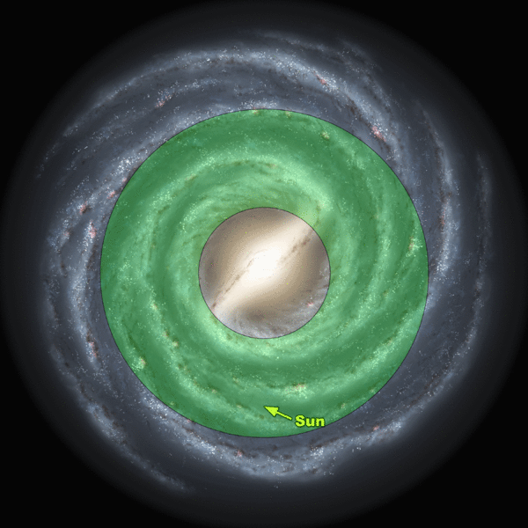

http://astro.unl.edu/naap/habitablezones/animations/stellarHabitableZone.html

http://www.post-gazette.com/opinion/editorials/2013/11/07/Planet-Goldilocks/stories/201311070205
Article on planets in the goldilocks zone…short and good.

