Name_________________________________
Notes: How did life evolve/start on Earth?

Urey-Miller Experiment

Scientist designed an experiment to test if __________________ on Earth could have initiated ______.

The Urey-Miller Experiment used __________ believed to be present on early Earth, an ___________ current (simulating lightning), and boiling _______________. They found that _______________ organic ____________________ were created in a short amount of time.

Fill in the boxes from the animation: http://faculty.massasoit.mass.edu/whanna/122/page4/page29/page61/page61.html

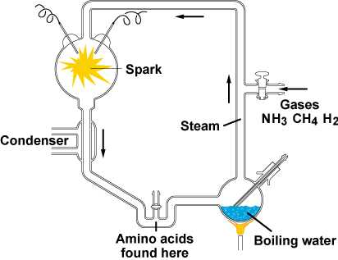

NASA Scientists create amino acids in space!
http://www.nasa.gov/centers/ames/news/releases/2002/02_33AR.html

Scientist shone ______________________ light on deep-space-like “__________” simulating conditions in ______________. Deep space ice is common water ice laced with simple molecules (used wood alcohol and ammonia).

Discovered amino acids (essential to life):

These can be made in _______________ interstellar ____________ where planetary systems and stars are made. Places where _________________ and ______________ are made.

The amino acids are ___________________ to ones found in carbon-rich __________________. Earth could have been “________________” with amino acids from ______________. This could have jump-______________ life on Earth.

In previous experiments, the irradiated interstellar ice “look-alikes” generated compounds called amphiphiles that can organize themselves to form ________________________; and molecules called quinones that play important _______________ in the metabolism of all living organisms on Earth.

