Name_________________________________
Notes: How did life evolve/start on Earth?

Urey-Miller Experiment

Scientist designed an experiment to test if conditions on Earth could have initiated life.

The Urey-Miller Experiment used gases believed to be present on early Earth, an electric current (simulating lightning), and boiling water. They found that complex organic molecules were created in a short amount of time.

Fill in the boxes from the animation: http://faculty.massasoit.mass.edu/whanna/122/page4/page29/page61/page61.html

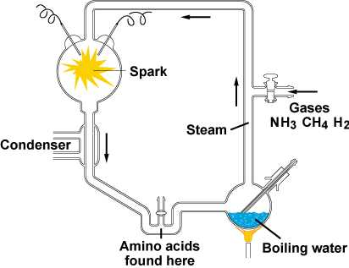

NASA Scientists create amino acids in space!
http://www.nasa.gov/centers/ames/news/releases/2002/02_33AR.html

Scientist shone ultraviolet light on deep-space-like “ices” simulating conditions in space. Deep space ice is common water ice laced with simple molecules (used wood alcohol and ammonia).

Discovered amino acids (essential to life):
- glycine
- alanine
- serine

These can be made in dense interstellar clouds where planetary systems and stars are made. Places where planets and stars are made.

The amino acids are common to ones found in carbon-rich meteorites. Earth could have been “seeded” with amino acids from space. This could have jump-started life on Earth.

In previous experiments, the irradiated interstellar ice “look-alikes” generated compounds called amphiphiles that can organize themselves to form membranes; and molecules called quinones that play important roles in the metabolism of all living organisms on Earth.

