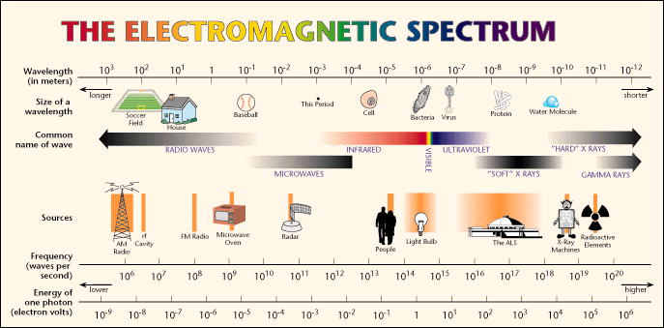

**ELECTROMAGNETIC SPRECTUM**

2. ______________________

4.________________________

6. ___________________

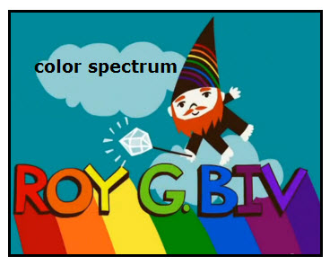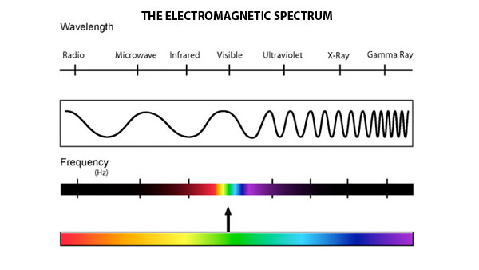

15. _______________, ___________________, ______________________, _____________________, ______________________, _____________________, ________________

11. ______________ Wavelength

7. ______________________

9. _________________ Frequency

13. ________________ Energy

12. ________________ Wavelength

10. ________________ Frequency

8. __________________

1. __________________________

5. ____________________

14. _____________ Energy

3. ______________