Earth formation notes

Step 1: Around 5 billion years ago a cloud of gas and dust, left over from a supernova explosion, started to collapse under its own gravitation force.

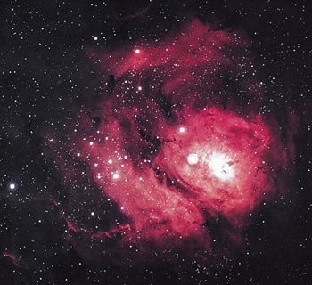
Evidence: Any elements above iron are fused in a supernova explosion. Elements from helium to iron are fused inside a star, a star can’t fuse past iron.

Picture:

Step 2: Gas and dust start to spin and flattens the cloud into a disk, a bulge forms in the middle, and a protostar (no nuclear fusion yet) has developed.

Evidences: a sphere will flatten as it spins and accelerates inward. Most of mass in our solar system is in the sun (99%).
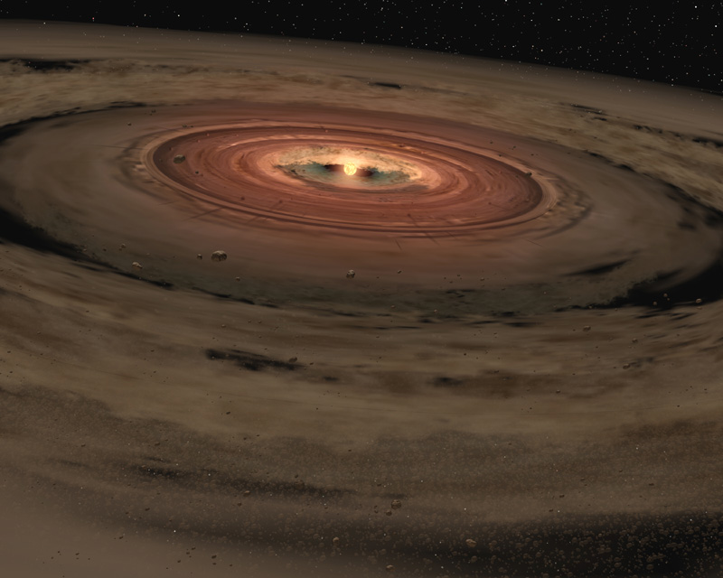
Picture:

Step 3: Disk gets compressed more in the center, nuclear fusion starts, which initiates the solar winds (charged particles) that blow away the less dense material into outer solar system, the more dense material remains close to the sun.

Evidence: First four planets are dense and rocky, while outer four are less dense. Mercury is the most dense planet, while Saturn can float in a bathtub.

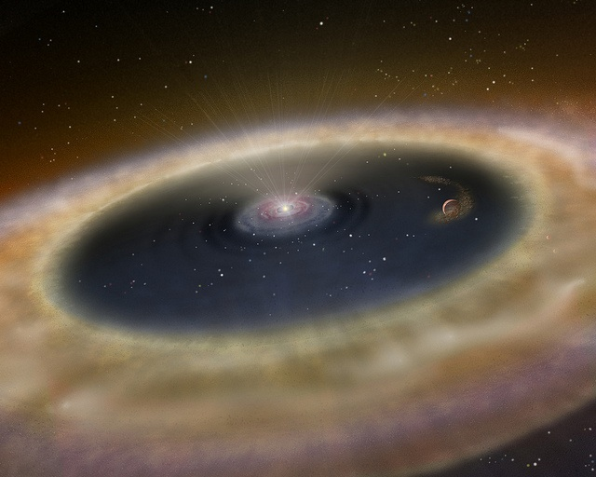
Picture:

Step 4: Planetessimals have formed from remaining disk material, and continue to accrete into protoplanets. Earth is still growing at this time.

Evidence: Heavy bombardment period, can see on smaller objects like the moon and Mercury. Earth is still accreting today with 100 tons of material a day. Mercury had outer crust knocked off, moon formed from impact, Mars hit by a large object.
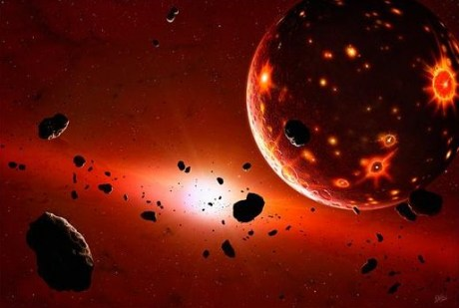
Picture:

Step 5: Around 4.5 billion years ago, Earth is “fully” formed. Heat due to impacts of comets, meteors and asteroids along with nuclear decay cause the Earth to heat up and become completely molten.

Evidence: Dense material sinks to form core, less dense rises to forms the crust. Earth has to be liquid to do this. Oldest rock are around 4.1 bya.
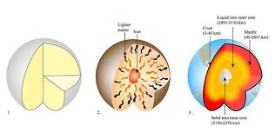
Picture:

Step 6: Earth continues to cool, first island forms, oceans condense out of atmosphere, then continents forms, early life starts around 3.5 bya. Earth’s surface and atmosphere is transformed from life.

Evidence: fossil evidence of stramatolites, amount of CO2 locked up in rocks, other planets atmosphere, banded iron formation.

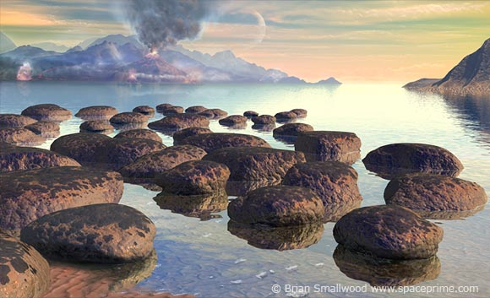
Picture:

