Name ________________________________ Date ______________ Block ___________

Put the pictures in correct order (1-5), label each one with what has formed (sea stack, sea cave, sea stumps, sea cliff, or sea caves)

#_____
#_____
#_____

#_____
#_____

Show how the waves would refract as they come ashore. Assume the waves are coming directly towards shore.
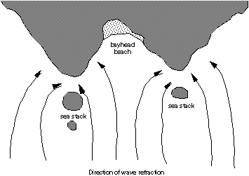

Picture Walk Around: (Sea Stack, Sea stump, Wave cut platform, Sea arch, Wave cut notch)

- ______________________________ and ________________________________

- ______________________________

- _____________________________ ( High Tide OR Low Tide) because ……

- _____________________________

- _____________________________

- _____________________________ ( High Tide OR Low Tide) because ……

- _____________________________ and ___________________________________

- Greatest ___________, ____________ because ____________________________________________

Least __________. _________________ because ___________________________________________

- _____________________________

10. Show how this cliff might evolve over time, try to show wave cut platforms, sea arches, stacks, etc.

